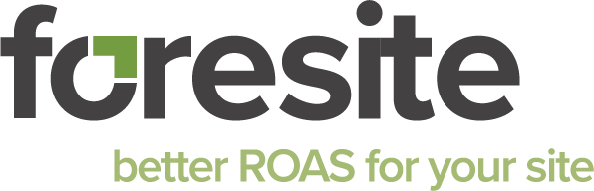
Meta (Facebook/Instagram) Onboarding Instructions
Share your assets with Foresite — Business ID: 759278250814092

Please add Foresite as a **Partner** with **Admin access** to the assets below. Using the partner method keeps ownership with you and allows us to manage campaigns safely.
Quick Checklist (share all that apply)
- Facebook Page(s) — Admin
- Ad Account(s) — Admin
- Pixel / Dataset — Admin
- Instagram Account (optional, if you want IG ads) — Admin

Where to do this
Meta Business Settings → Select the asset → **Assign Partners** → enter Business ID and choose **Admin**. You can also go to **Users → Partners → Add → Give a partner access to your assets** and select assets in bulk.

Facebook Page
- Open Business Settings.
- Go to **Accounts → Pages** and select your Page.
- Click **Assign Partners**.
- Enter Business ID **759278250814092**.
- Select **Admin access**, then **Save/Confirm**.

Pixel / Dataset
Sometimes labeled as Pixels under Data Sources; some accounts show Datasets.
- Open Business Settings.
- Go to **Data Sources → Pixels** (or **Datasets**) and select your main pixel/dataset.
- Click **Assign Partners**.
- Enter Business ID **759278250814092**.
- Select **Admin access**, then **Save/Confirm**.

Ad Account
- Open Business Settings.
- Go to **Accounts → Ad accounts** and select the ad account used for your ads.
- Click **Assign Partners**.
- Enter Business ID **759278250814092**.
- Select **Admin access**, then **Save/Confirm**.

Instagram Account (optional, for IG ads)
- Open Business Settings.
- Go to **Accounts → Instagram accounts** and select your handle.
- Click **Assign Partners**.
- Enter Business ID **759278250814092**.
- Select **Admin access**, then **Save/Confirm**.

Troubleshooting Tips
- If **Assign Partners** is grayed out, you may not be the asset owner. Check the asset owner and have the owner share it or transfer ownership.
- If you don’t see **Instagram accounts**, connect your IG to the Facebook Page or convert the IG to a Professional account.
- If the ad account or pixel is not in your Business Manager, first **Add** it to your Business (Add → Add an account / Request access).
- Only a Business Admin can assign partner access. Ask an admin on your team if needed.

Confirmation
Please reply once complete: “Meta access granted (Page, Pixel/Dataset, Ad Account, Instagram).”

